Adam Yeary

Sustainable Urbanism Reflection

Professor Mingming

May 23, 2013

Reflection

Staying in contact with family members was very important to me, and probably most students, while on a trip of this magnitude. In order to avoid a large phone bill once the trip is over, there are two main options to pursue. The first option is to contact your cell phone provider and purchase a temporary international phone plan. These aren’t too expensive and are certainly cheaper than using your phone normally. The second option is to use one or a combination of the many services that make use of the internet. Most of these options are free or very cheap compared to using your phone normally or even buying an international plan. Some examples of these services include Skype, iMessages, Facetime, or any number of other messaging applications. Skype offers free video calls and very cheap voice calls to land lines or mobile phones. Facetime and iMessages are Apple specific programs but both offer free means of communication with access to Internet. I mainly used iMessages and emails to stay in touch with my parents. One thing to keep in mind is the time difference. The part of China we were in was exactly 12 hours ahead of the east coast in the US so it was very easy to figure out what time it was at home.

Money in China was never a major issue while I was there. Before I left I converted some cash and took it with me incase I needed money immediately. I also had a credit card that does not charge any fee for international transactions. I thought this was a pretty awesome feature and planned to use it a lot. However, not may places accepted my credit card. I’m not sure why since they had credit card readers, but for some reason my card wasn’t accepted. Because of this, I mainly used yuan for purchases. ATMs were pretty frequent, but you do have to make sure they accept Mastercard or Visa. There was a fee associated with international withdrawals on my debit card so I made sure to try to limit the number of withdrawals to avoid the fees.

As far as packing is concerned, I had a difficult time deciding what to bring and what to leave. Since no one can know what the weather will be like every day, I tried to be prepared for some variety. The weather while we were there was pretty moderate. It was never that cool, I never needed a jacket or even jeans really. But it did get very warm during the day a couple different times. So if I were going again, I would definitely plan for warm weather.
I also think I had one of the biggest suitcases of the whole group. This seemed annoying until it came time to pack for the return trip. While I probably overpacked, I had plenty of room for everything including souvenirs. I managed to pack enough clothes that I did not need to worry about doing laundry, which made up for the heavier suitcase.

The topic that my group researched for our trip to China was renewable energy practices in China. Before we went, research was done about bigger projects under way in the country. We looked into solar, wind, and hydro projects. They have government issued Five Year Plans which address many aspects of life in China including renewable energy. This plan set a goal of 21 GW generation from solar energy by 2015. There are two notable examples in China which are Golmud Solar Park and Lijiang Solar Station. Golmud generates approximately 300 gigawatt hours per year and Lijiang is expected to generate close to 300 megawatts. In the wind sector, China is beginning to move wind farms off shore. An example of this is the Tangshanpeng Wing Farm which generates 26 MW of offshore wind energy. China also has many notable hydroelectric. For example, the Three Gorges Dam which has the highest capacity in the world at 18200 megawatts capacity.
While we were in China we saw many examples of renewable energy sources being used. One of the most prevalent technologies I saw was hot water heaters on the roofs of buildings These heaters use solar energy to heat water instead of electricity from nonrenewable sources.
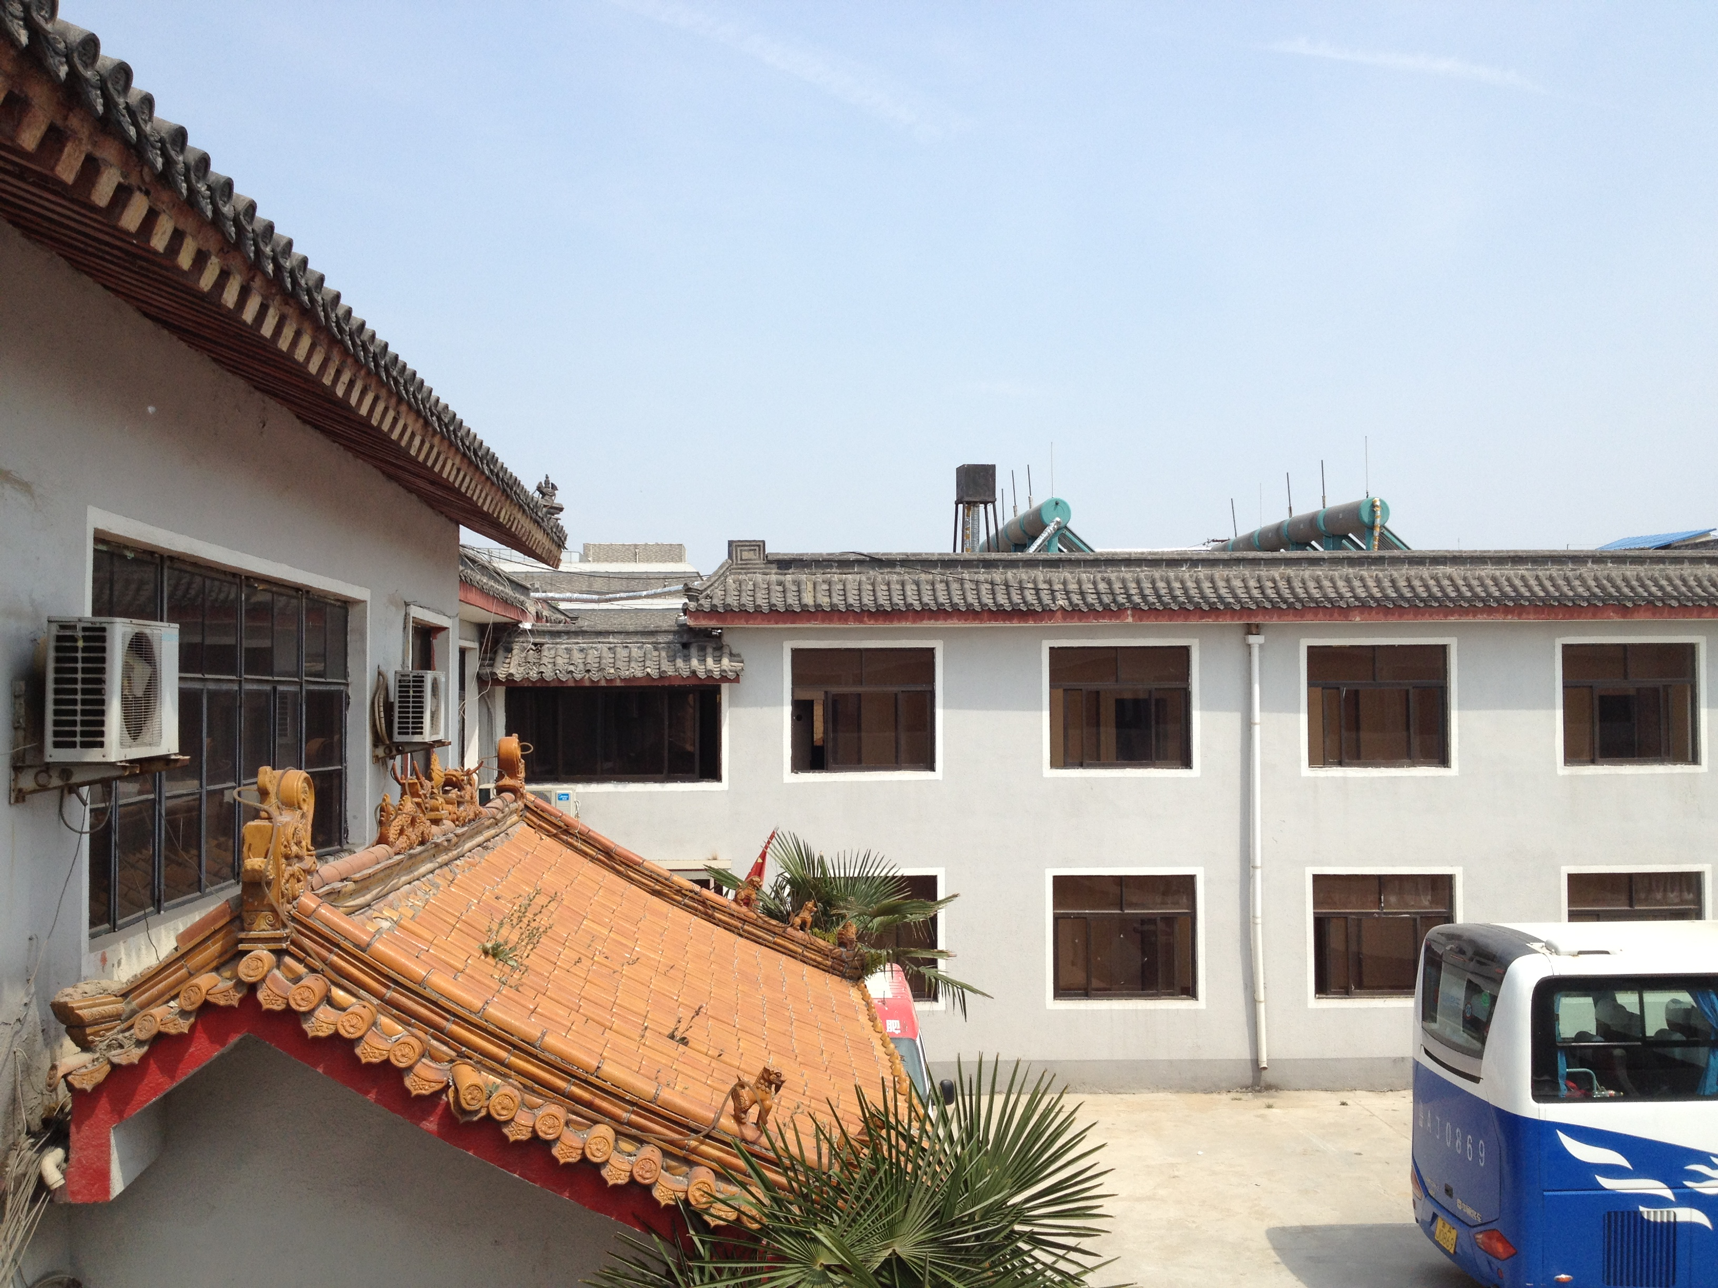
I also saw street lamps that use solar panels to power them instead of using electricity from energy sources such as coal. Buildings are also beginning to implement solar panels. One of the most famous buildings, we actually visited. It is the engineering building at Tsinghua University. A picture of this building is shown below.
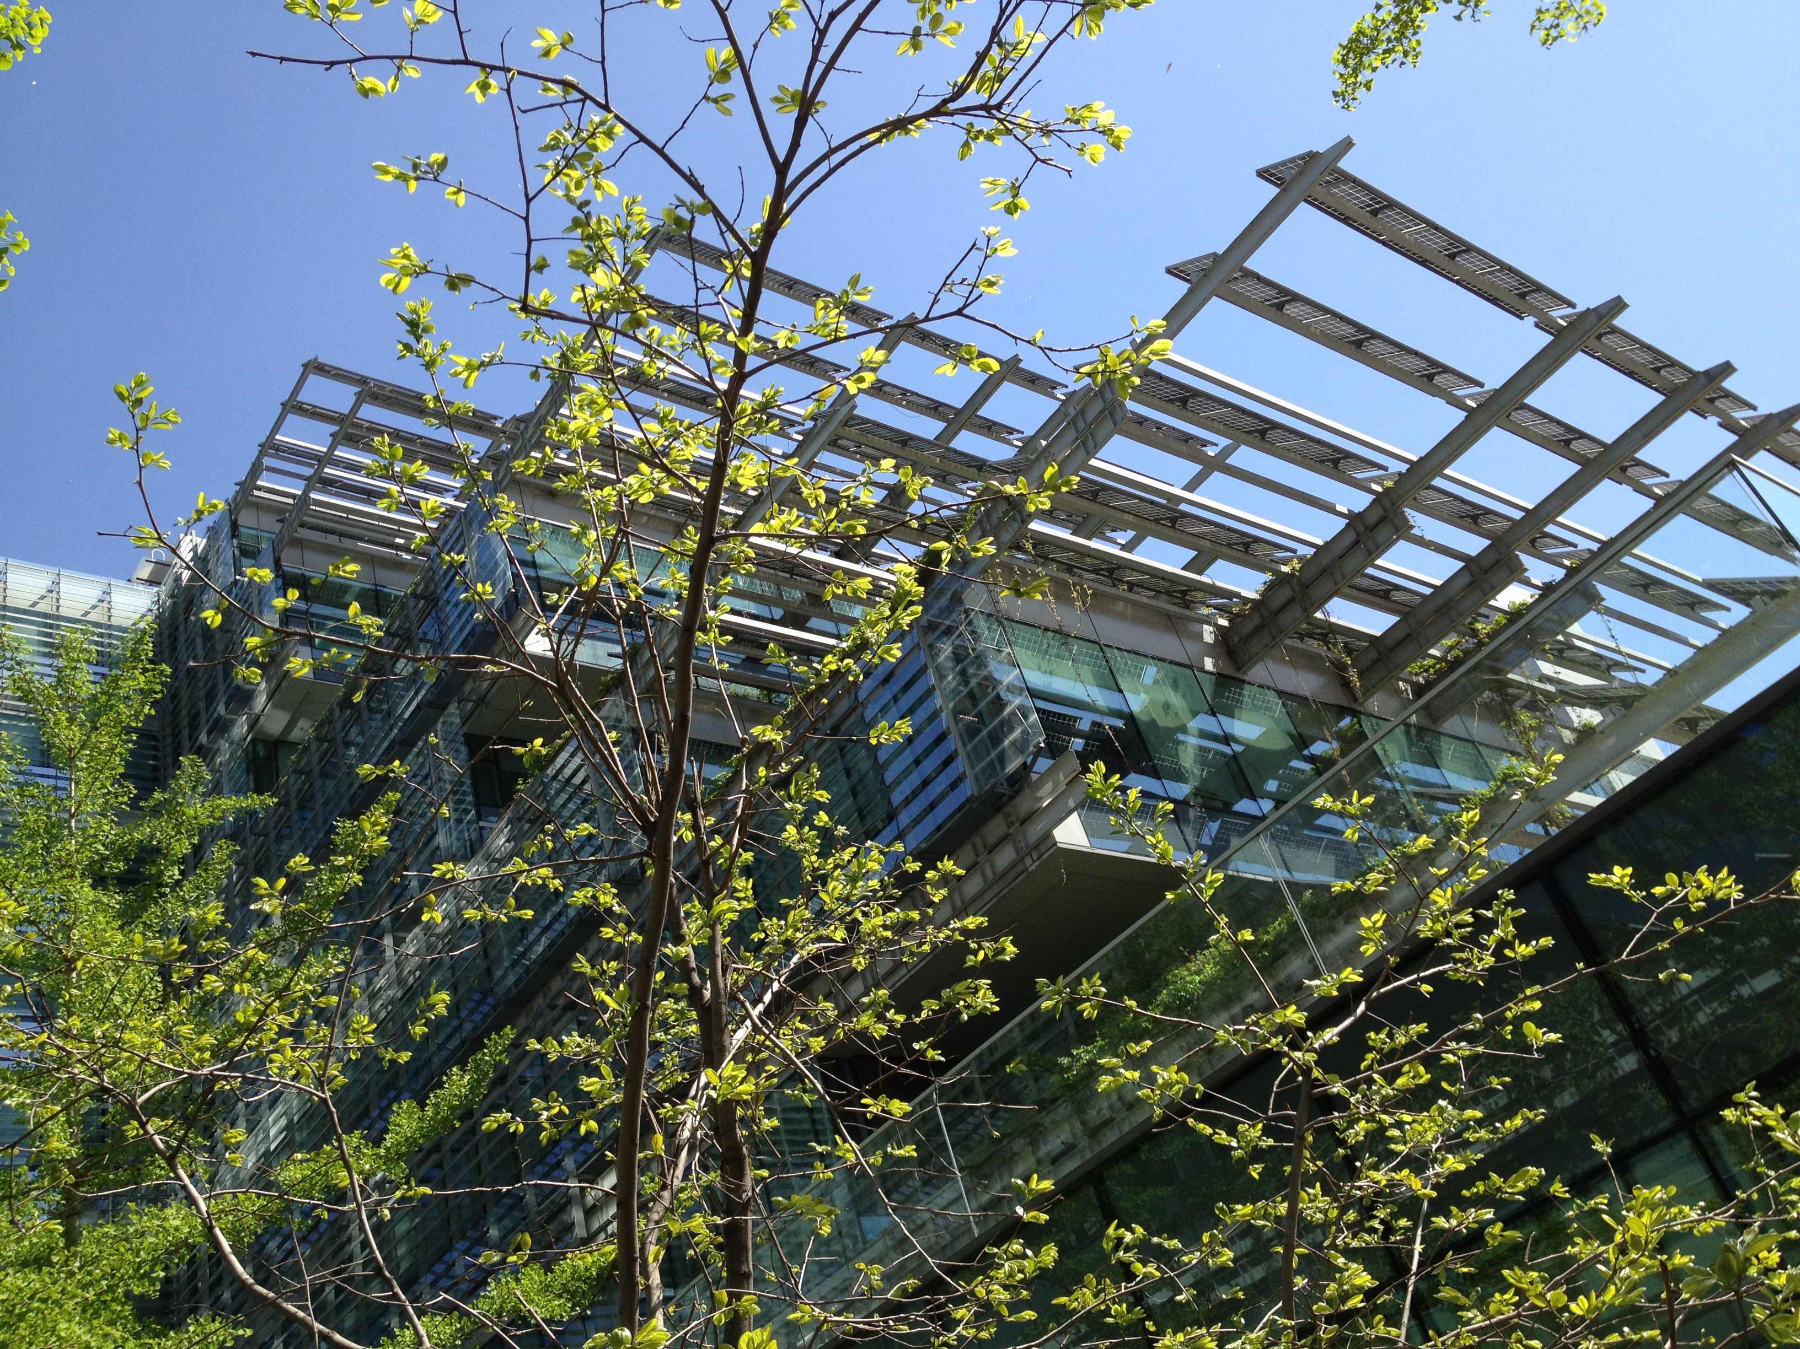
These panels help to reduce the demand on coal power plants.
Natural gas is also beginning to play a part in the transportation sector. One of the friends I made in China has been telling me about how taxis and BRT buses are beginning to incorporate natural gas. Below are a few pictures of this being used. China has also began to work on a pipeline that will transfer natural gas across the country. A friend that I made in China, told me that her family uses natural gas for cooking.
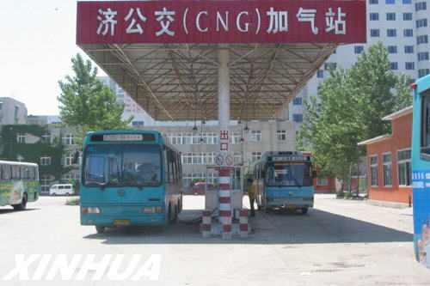
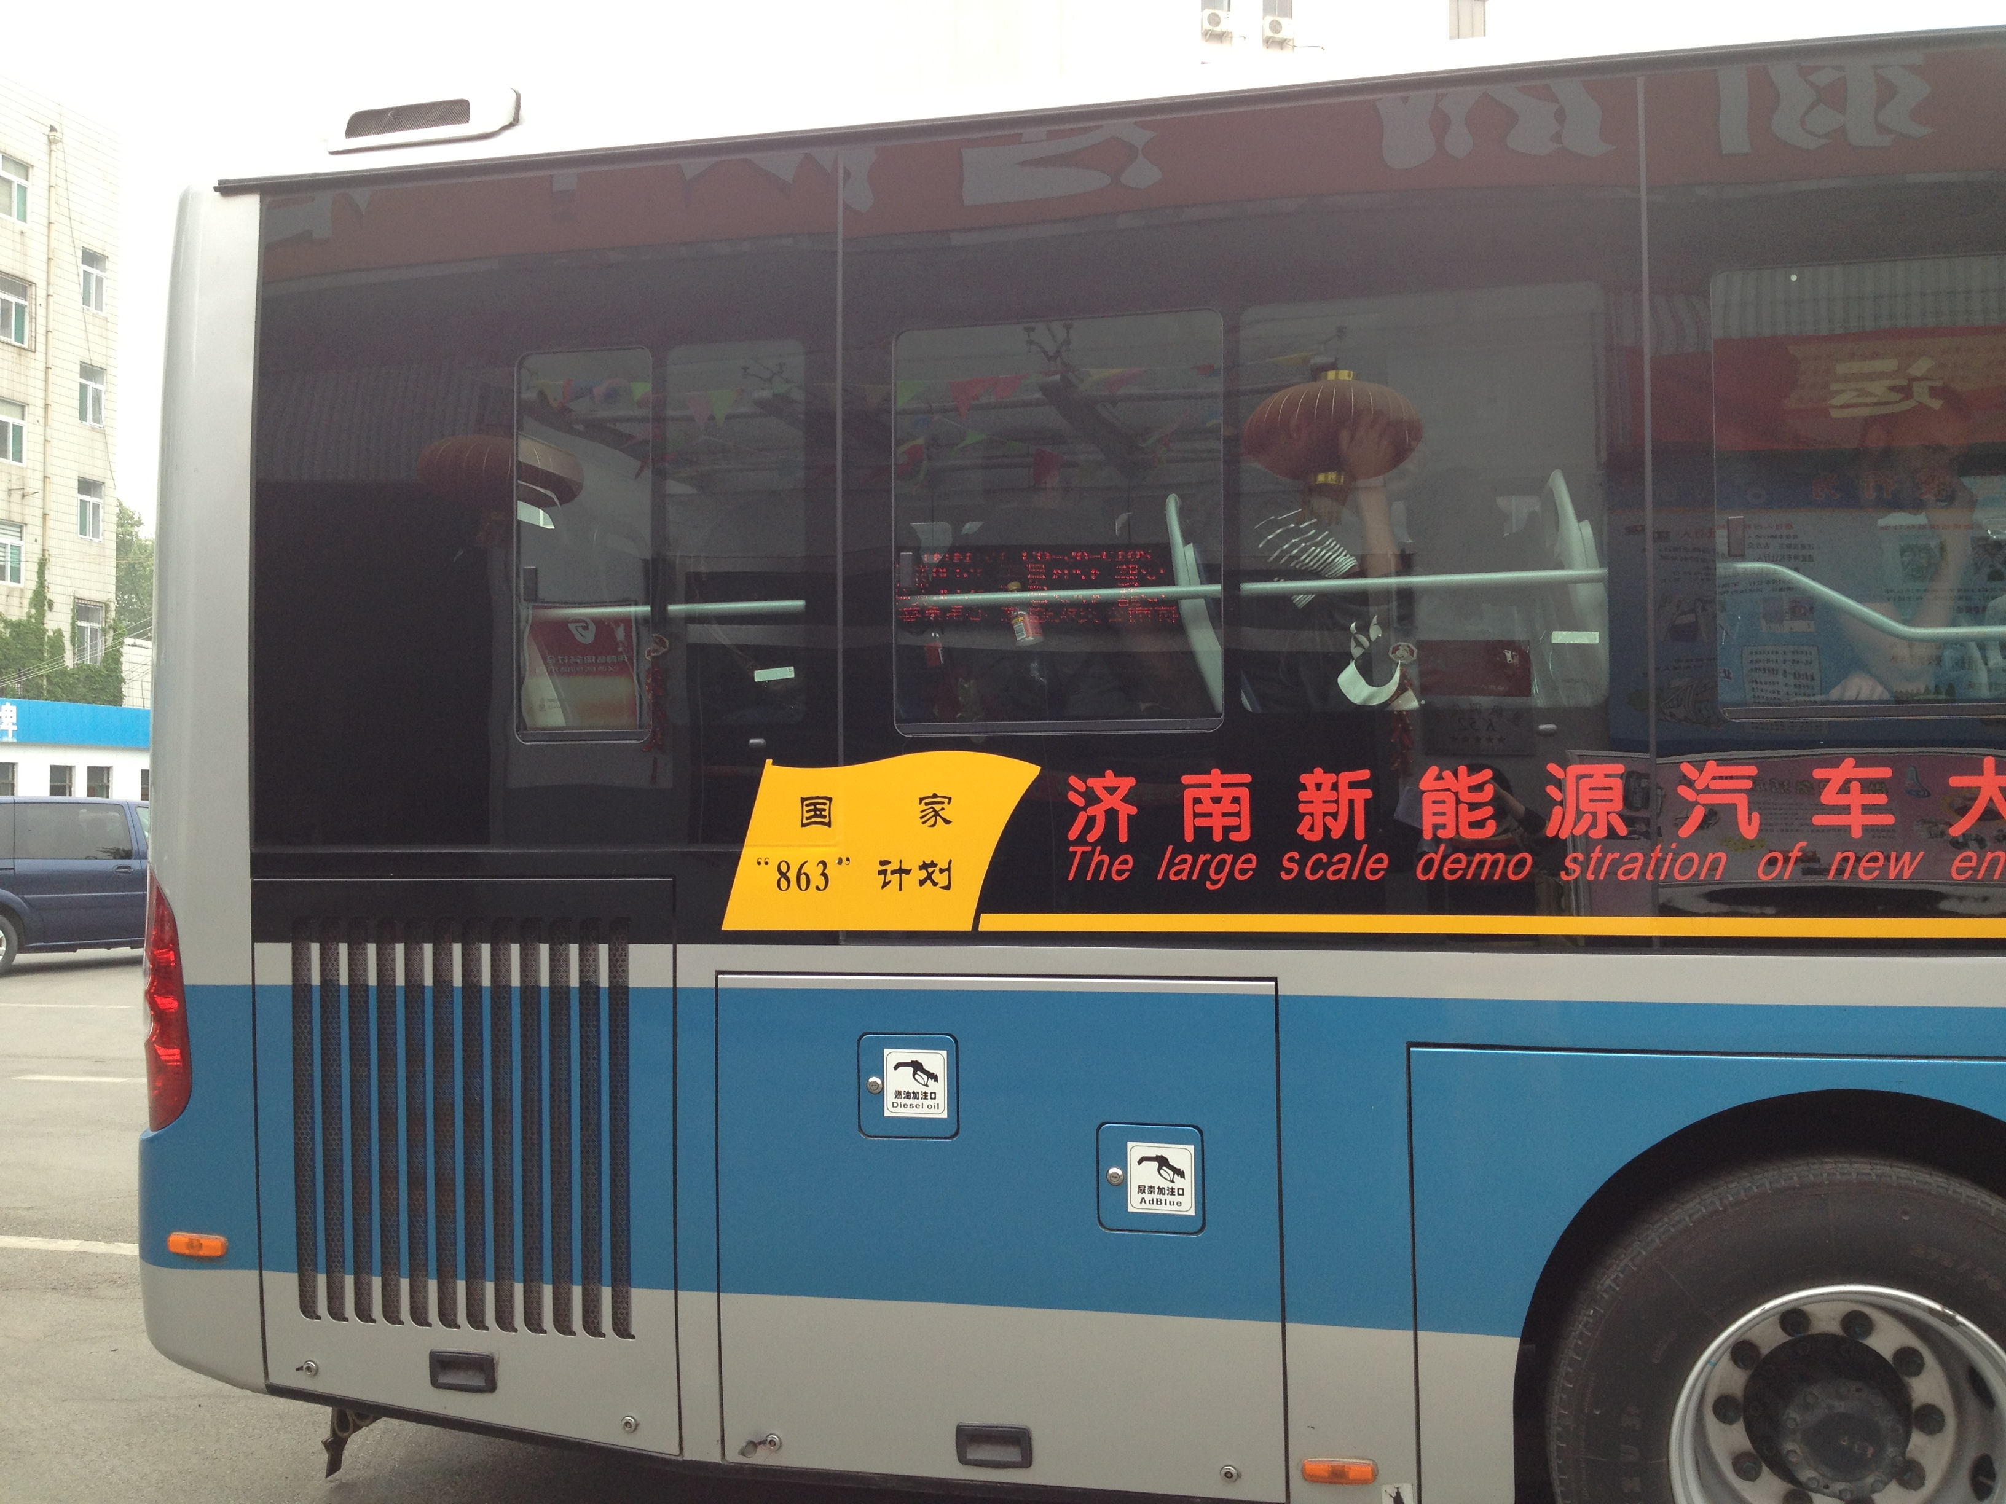
While we were in China we did not see much use of wind energy on the personal scale. This is probably due to the technology’s need for scale to be really efficient. However, we did see a wind farm as we were approaching Beijing on the plane. I tried to get a picture but it was not clear enough to see all the turbines.

Overall, I have learned about major renewable energy installations that are in China through research done before we left for China. These types of sights are easy to do research on over the internet. However, I have also learned about more personal forms of renewable energy being used in China. These examples include the solar hot water heaters and solar panels on buildings and lights. I feel like these examples cannot really be experienced through the internet, but are best seen and learnt about in person and through firsthand experience. For example, several of the methods I have learned about are from a friend I made in China. This type of experience can only come from a study abroad experience in China.

Before I left on this trip I thought it would provide me with a once in a lifetime experience. Now, after having been, I feel like it might not be “once in a lifetime” anymore. I really liked the balance that seemed to be struck between playing the tourist and getting to see the side of China most tourists wouldn’t. One area for improvement could be a better balance between scheduled activities and free time.

