Michael Knadler
Homework 1

Jinan is the capital of the Shandong province and is located approximately five hours south of Beijing. Jinan is nicknamed the City of Springs due to the large number of springs found in the area. There are “72 Famous Springs” that can be found throughout the city, the most popular of which is Baotu Spring. The springs flow north and converge into Daming Lake, which is surrounded by many historical buildings, temples and halls. The main square in Jinan is Quancheng Square, also known as Spring City Square. Southeast of the city is Thousand Buddha Mountain (also known as Qianfo Mountain), named for the numerous images and statues found on the mountain, many of which are carved directly into the mountain itself. Also southeast of the city is the Four Gates Pagoda, the oldest one story stone tower in China. Nearby is the Thousand Buddha Cliff that houses a large collection of Tang Dynasty Buddhist statues. The region is also home to several museums and libraries including the Shandong Provincial Museum, the largest museum in the province, the Jinan Municipal Museum, and the Shandong Provincial Library. About 130km south of Jinan is Qufu, the hometown of Confucius. As such, Qufu is home to three Confucian sites recognized as UNESCO World Heritage sites: the Temple of Confucius, the Cemetery of Confucius, and the Kong Family Mansion.

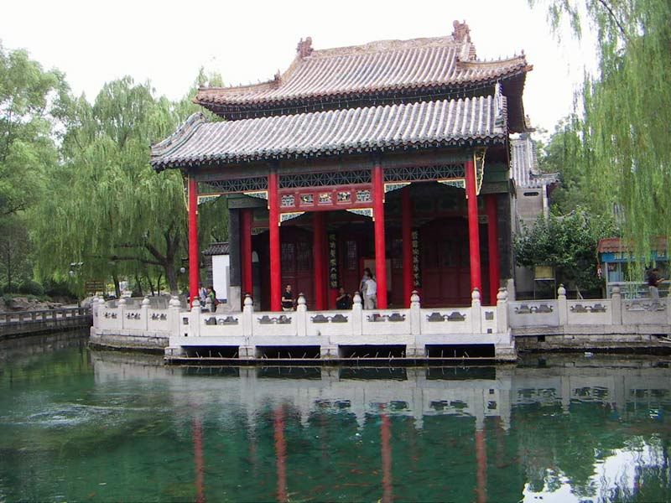
Baotu Spring Park
http://www.chinadiscover.net/china-tour/shandongguide/shandong-jinan-baotu-spring-park.htm

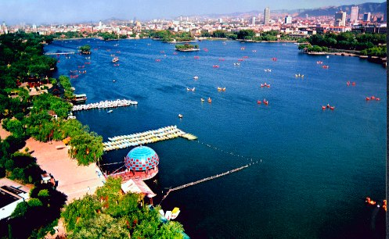
Daming Lake Park
http://www.chinauniquetour.com/arts.asp?id=3664

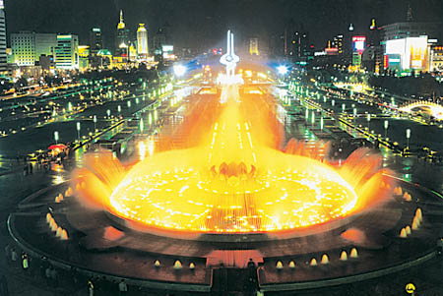
Quancheng Square
http://news.everychina.com/vz405c6a-quancheng_square.html

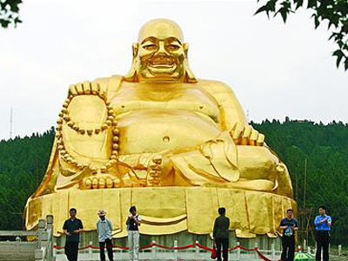
Thousand Buddha Mountain
http://www.topchinatravel.com/china-attractions/thousand-budhha-mountain.htm

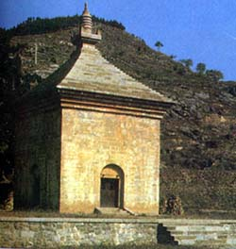
Four Gates Pagoda
http://www.chinaetravel.com/attraction/att24n.html

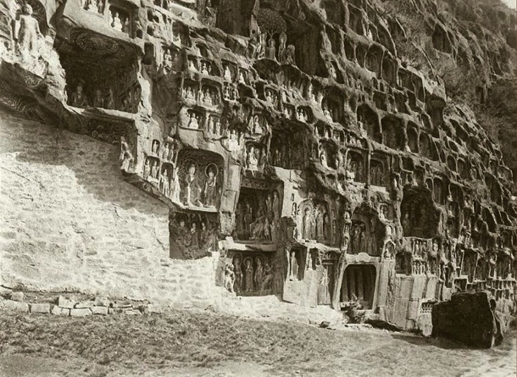
Thousand Buddha Cliff
http://www.chinaheritagequarterly.org/features.php?searchterm=024_cliffs.inc&issue=024

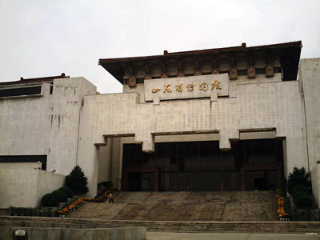
Shandong Provincial Museum
http://www.topchinatravel.com/china-attractions/shandong-provincial-museum.htm

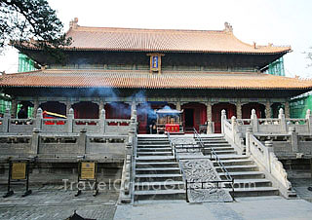
Temple of Confucius
http://www.travelchinaguide.com/attraction/shandong/qufu/temple.htm

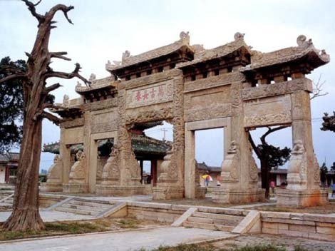
Cemetery of Confucius
http://history.cultural-china.com/en/49H140H807.html

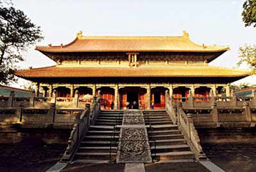
Kong Family Mansion
http://www.chinaexploration.com/TopAttractions/Family-Mansion-of-Confucius-in-Qufu.html

